# POWER BI LAB - LAB 4_Data Visualization, Analytics, Charts, and Dashboards II

# THEORY: Waterfall Charts in Power BI

# LAB 1: Treemaps in Power BI

## When to use Treemap Visuals

Treemaps display hierarchical data as a set of rectangles. Each level of the hierarchy is represented by a colored rectangle called a ***branch* node**. Each branch contains smaller rectangles called ***leaf* nodes**. Power BI uses the measure value to determine the rectangle size for branches and leaves. The rectangles are arranged by size with the largest branch node at the top left and the smallest branch at the bottom right. The arrangement of the leaf nodes within each branch follows the same order. Treemaps are a great choice for many scenarios:

* Illustrate the proportions between each part and the whole
* Present a large number of values that can't be effectively shown with bar charts
* Show values by using size and color coding.
* Identify patterns, most-important contributors, and exceptions.

## Get the data for the lab

1. Download the Retail Analysis Sample PBIX file to a folder of your preference on your desktop from Week 4 Folder.
2. In Power BI Desktop, select **File** > **Open** and browse your files to select the **Retail Analysis Sample** file and **Open** it. You can explore this files and as you can see, it contains sales data and visuals.
3. At the bottom, select the green plus symbol  to add a new page to the report. Name this page **Treemap Visual**.

## Create the Treemap Visual

The goal is to display sales by product category.

1. In the **Data** pane, expand **Sales** and select the **Last Year Sales** checkbox. Power BI presents the data as a column chart.
2. Check to see that the **Last Year Sales** field is in the **Y-axis** for the chart in the **Visualizations** pane.

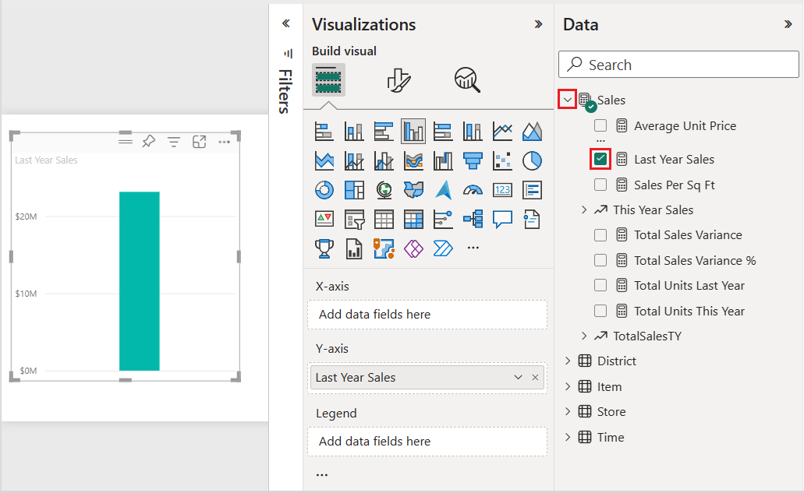  
  
Add a Category Field

1. Convert the visualization into a treemap by selecting the **Treemap** visual in the **Visualizations** pane.

This action exposes the **Category** and **Details** sections in the **Visualizations** pane. The *Last Year Sales* data becomes the **Values** for the chart on the **Visualizations** pane.

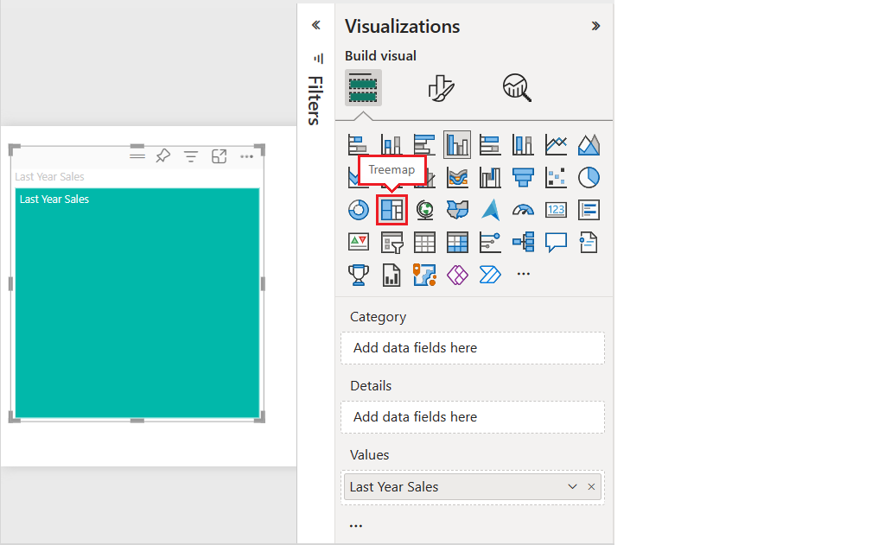

1. Make sure your visual is selected (you select a visual by simply clicking on it) Then, In the **Data** pane, expand **Item** and select the **Category** checkbox.  
   Power BI updates the treemap to show the size of the rectangles based on total sales by product. The rectangle color represents the product category. The hierarchy visually describes the relative size of total sales by product category. The **Men's** category has the highest sales and the **Hosiery** category has the lowest.  
   A screenshot of a computer screen

   Description automatically generated
2. Adjust the size of your Treemap visual to cover about half the space of the left side of your report.  
     
   A screenshot of a computer

   Description automatically generated

Add a Details Field

1. In the **Data** pane, expand **Store** and select the **Chain** checkbox. You can now compare last year's sales by category and store chain.

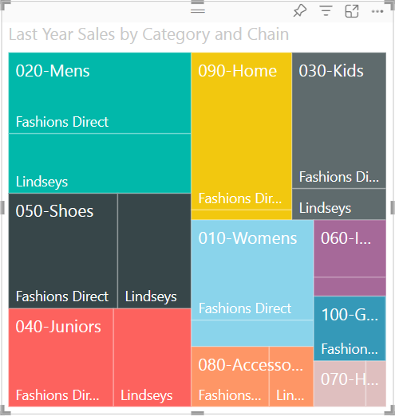

1. On the treemap, hover over **Fashions Direct** in the **090-Home** rectangle to see the tooltip for Fashion Direct's portion of the Home category. If your numbers are not identical to those in the image, it is not important.

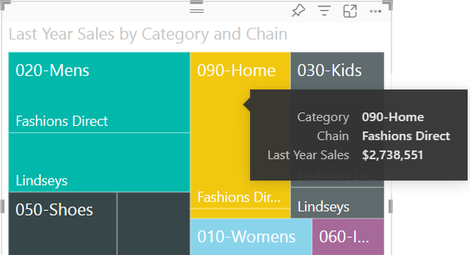

## Copying Visuals from One Report Page to Another

When you highlight a **Category** or **Details** item in a treemap, Power BI cross-filters the other visualizations on the report page. Consequently, for this exercise, we will need at least one other visual on the report page with the treemap.

1. Select **File** > **Save** to save your Treemap report.
2. At the bottom of the screen, click on the page **Overview**. This page contains multiple visuals.
3. Click on the pie chart visual at the top left of the page to select this visual. Then, right click and select **Copy** > **Copy visual**.

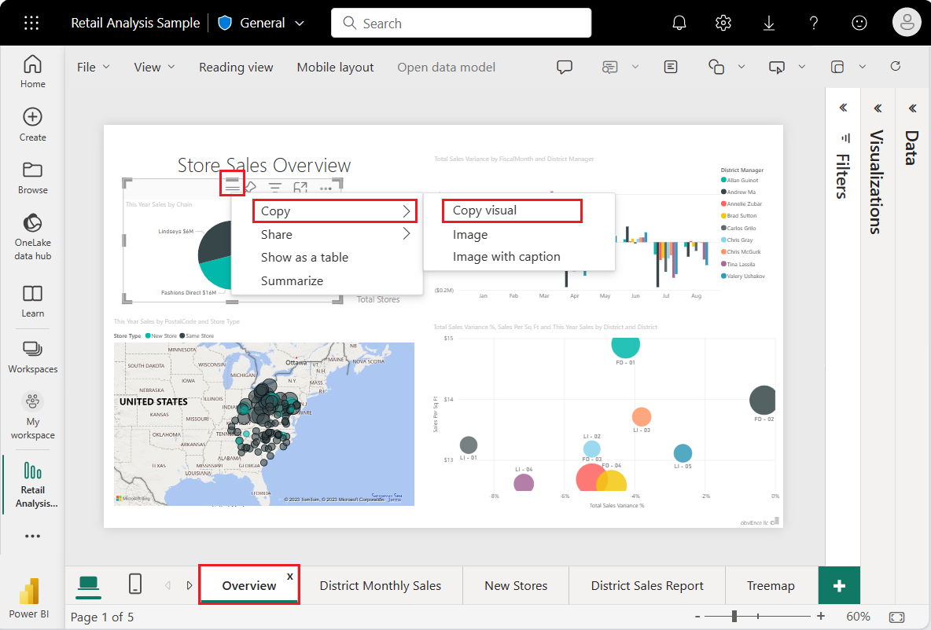

1. Switch back to your **Treemap** report page. Enter CTRL + V and paste the copy of the pie chart visual to the right of the Treemap visual so that it covers half of the page of the report. Your report should look like the one in the image below (It does not have to be identical):  
     
   A screenshot of a computer

   Description automatically generated

## Cross-filtering in Power BI Visuals

1. Click the treemap visual to select it and expose its properties in the **Visualizations** and **Data** panes.  
     
   Use the Treemap to Cross-Filter the Pie Chart
2. In the treemap, select a **Category** or a **Chain** within a **Category**. This action cross-highlights the other visualizations on the page. When you select **050-Shoes**, the visualization shows that last year's sales for shoes was **$2,174,185** in **Fashions Direct**.   
     
   Use the Pie Chart to Cross-Filter the Treemap
3. In the pie chart, click on the **Fashions Direct** slice to cross-filter the treemap. Power BI highlights the sales for **Fashions Direct** in the treemap. This is how your report will look like.

## Format the Report

# LAB 2: Waterfall charts in Power BI

Waterfall charts are useful for understanding how an initial value (like net income) is affected by a series of positive and negative changes. Each measure (net income) change becomes a column on the chart. The columns are color coded so we can quickly notice increases and decreases across the time series data. The position of the columns can fluctuate between the initial and final values. The resulting view creates a picture similar to a concave or convex wave or a random waterfall cascade. Waterfall charts are also called *bridge charts*.

## When to use waterfall charts

Waterfall charts are a great choice for many scenarios:

* Present changes for a measure (number) across time or other series.
* Understand major changes that contribute to the total value.
* Plot your company's annual profit by showing various sources of revenue and arrive at the total profit (or loss).
* Illustrate the beginning and ending headcount for your company in a year.
* Visualize how much money you earn and spend each month, and the running balance for your account.

## Add a Page to the Report

Add a new page to your report by clicking on the plus tab  at the bottom of your report. Name this page **Waterfall Chart**.

## Create the Waterfall Chart

We will create a waterfall chart to display estimated sales versus actual sales by month.

1. On the **Data** pane, expand **Sales** and select the **Total Sales Variance** checkbox. Expand the width of the Data Pane if you cannot clearly see the fields. By default, Power BI presents the data as a clustered column chart. The *Total Sales Variance* should be in the **Y-axis** for the chart.

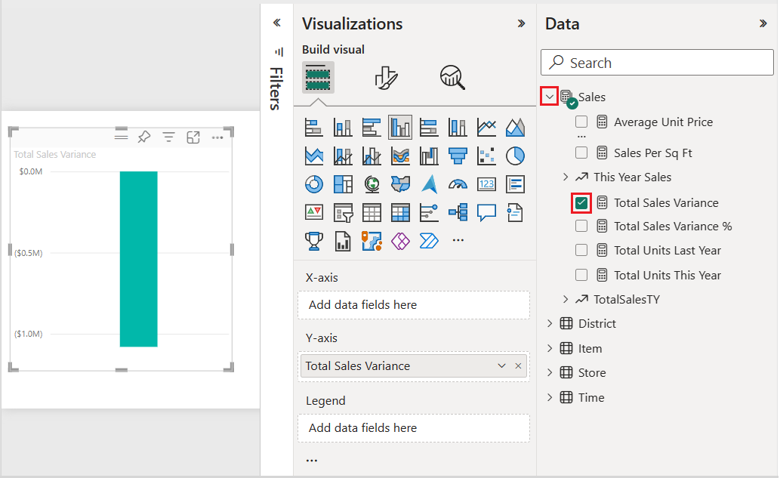

1. To convert the visualization into a waterfall chart, select **Waterfall chart** on the **Visualizations** pane.

This action exposes the **Category, Breakdown, and Tooltips** properties in the **Visualizations** pane.

1. In the **Data** pane, expand **Time** and select the **FiscalMonth** checkbox. Power BI updates the waterfall chart with the data in the FiscalMonth category. The initial view of the category data shows the values in ascending order.

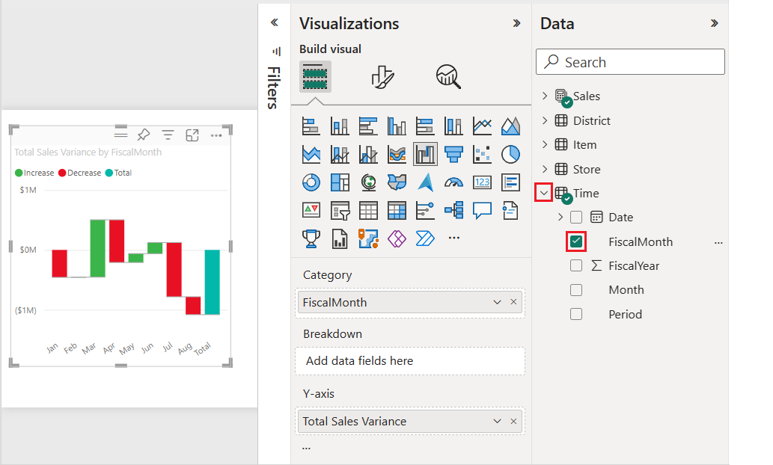

## Sort the Data in the waterfall chart

When Power BI creates the waterfall chart, the data is displayed in ascending or chronological order for the category. In our example, the data is sorted by month in ascending order, January to August, for the FiscalMonth category.

We will change the sort order to view different perspectives of the data.

1. At the top right of the waterfall chart, select **More options (...)** > **Sort axis** > **FiscalMonth**.

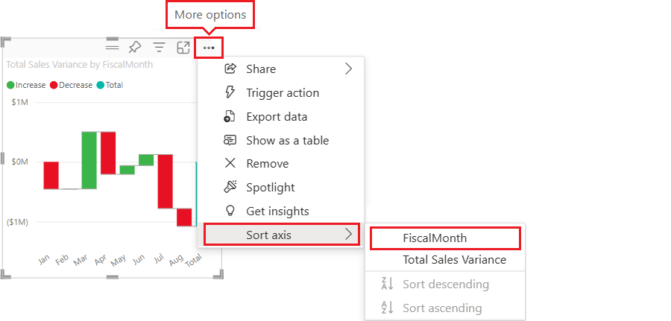

This action changes the sort order of the FiscalMonth category to **descending** by month. Notice that August has the largest variance and January has the smallest variance. Move the cursor of your mouse on each bar of the chart to identify the highest positive, lowest positive, highest negative and lowest negative sales variance (that is, amount of money that sales increased or decreased).

According to the chart below, the highest decrease in sales occurred in July while the highest increase occurred in March.   
  
1. Open the **More options (...)** > **Sort axis** menu.

Notice the checkmark next to **FiscalMonth** and **Sort descending**. A checkmark appears next to options represented in the chart visualization.

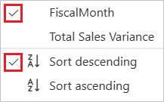

1. On the **More options (...)** > **Sort axis** menu, select **Total Sales Variance**.

This action changes the sort from the FiscalMonth category to the Total Sales Variance. The chart updates to show the Total Sales Variance data in descending order.   
  
1. On the **More options (...)** > **Sort axis** menu, change the sort back to **FiscalMonth** and **Sort ascending**.

## Explore the waterfall chart

Let's take a closer look at the data to see what's contributing most to the changes from month to month.

1. In the **Data** pane, expand **Store** and select the **Territory** checkbox. This action adds a corresponding **Breakdown** field in the **Visualizations** pane.

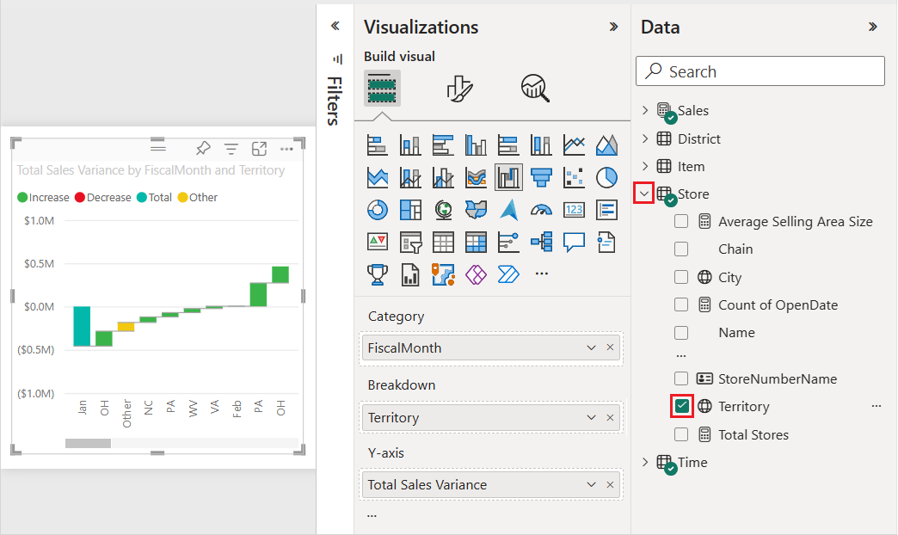

1. Power BI uses the **Territory** value in the **Breakdown** section to add more data to the visualization. The chart now includes the top territories for sales increases or decreases for each fiscal month. Hover your mouse over the smaller bars of the chart to obtain more details about that particular sales territory.

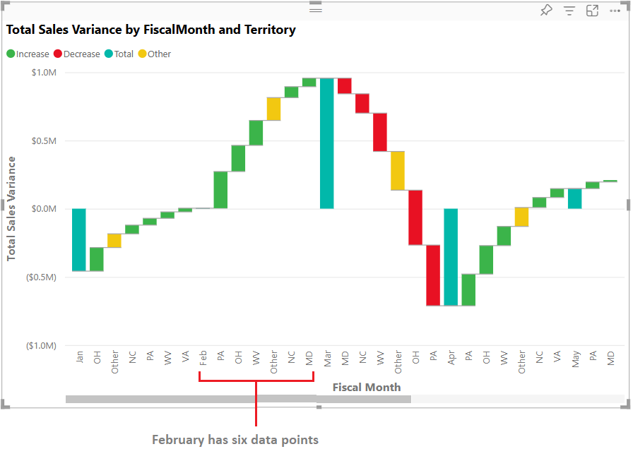

Let us say we are only interested in the top two territories (vontributors). You can configure the chart to highlight that information.

1. In the **Visualizations pane> Format visual** tab, select **Breakdown**, and set the **Maximum breakdowns** value to **2**.

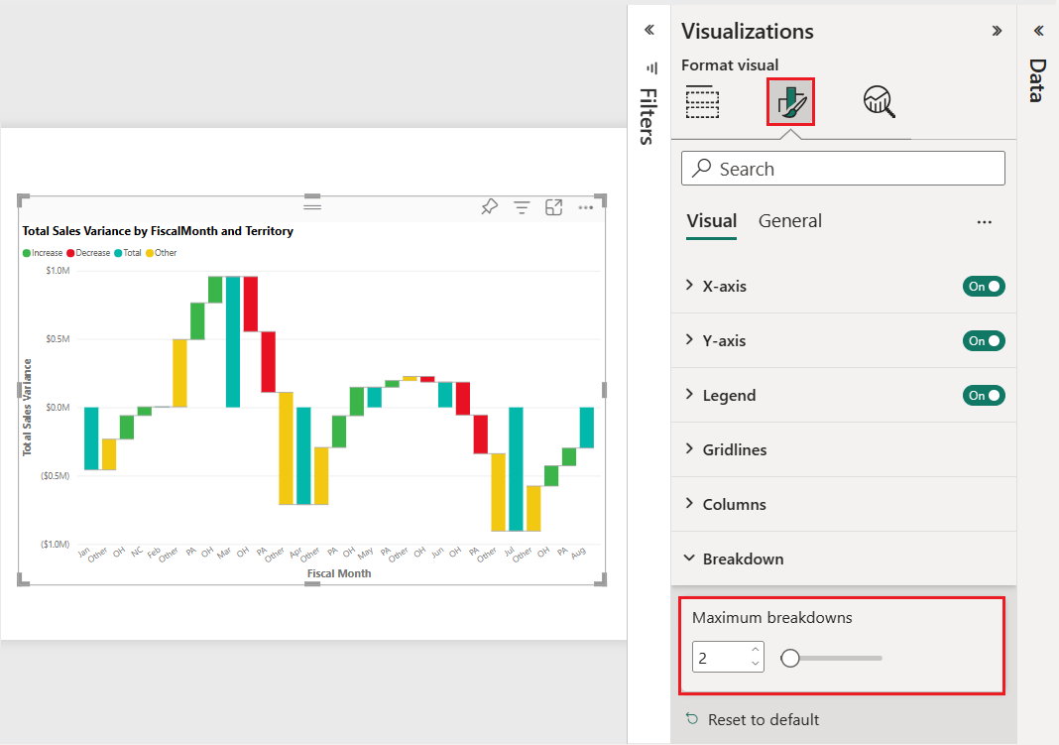

The updated chart reveals Ohio (OH) and Pennsylvania (PA) as the top two territories that are the largest contributors to increases and decreases.

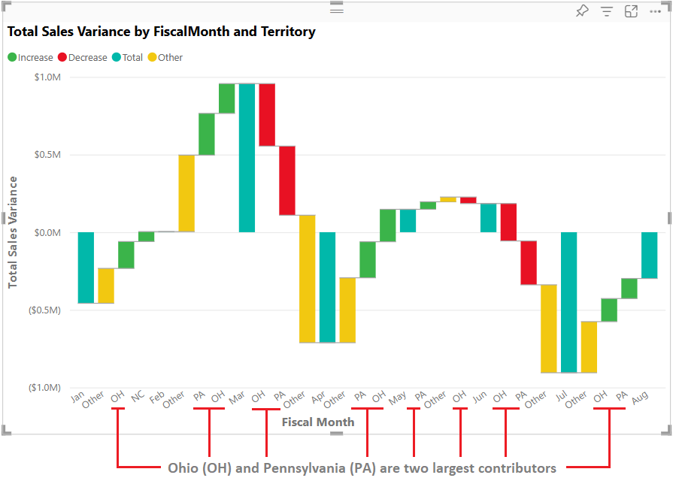

**LAB 3: Create a Q&A visual in Power BI**

The Q&A visual allows users to ask natural language questions and get answers in the form of a visual. They can use the Q&A functionality to quickly get answers to their data.

## Q&A autocompletes questions as we type

Even before you start typing, Q&A displays a new screen with suggestions to help you form your question. Start from one of the suggested questions or type your own question. Q&A supports a wide range of questions. You can:

* **Ask natural questions** Which sales has the highest revenue?
* **Use relative date filtering** Show me sales in the last year
* **Return only the top N** Top 10 products by sales
* **Provide a filter** Show me sales in the USA
* **Provide complex conditions** Show me sales where product category is Category 1 or Category 2
* **Return a specific visual** Show me sales by product as pie chart
* **Use complex aggregations** Show me median sales by product
* **Sort results** Show me top 10 countries/regions by sales ordered by country/region code
* **Compare data** Show me date by total sales vs total cost
* **View trends** Show me sales over time

## Word recognition with Red/Blue/Orange underlines

Q&A shows words with underlines to help you see which words the system recognized or didn't recognize. A **solid blue** **underline** indicates that the system successfully matched the word to a field or value in the data-model. An **orange dotted underline** indicates that the word or phrase is categorized as *low confidence*. If you enter a vague or ambiguous word, the field is underlined in orange dots. A **red double-underline** means Q&A didn't recognize the word at all.

## Create Q&A Visuals from Natural Engine Suggestions

## Add a Page to the Report

Add a new page to your report by clicking on the plus tab  at the bottom of your report. Name this page Visu **Q&A Visual**.

## Create the Visual

1. Click on the **Q&A visual** icon in the **Visualizations** pane.

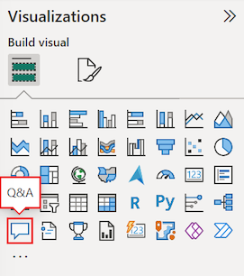

Power BI creates a new Q&A visual and supplies several Q&A suggestions to get you started, such as **top geo states by total OTHER units**.

1. Select the Q&A visual and drag the border to resize the visual up until you can see all the Q&A blue rectangles or up until you have reached the right border of your report.

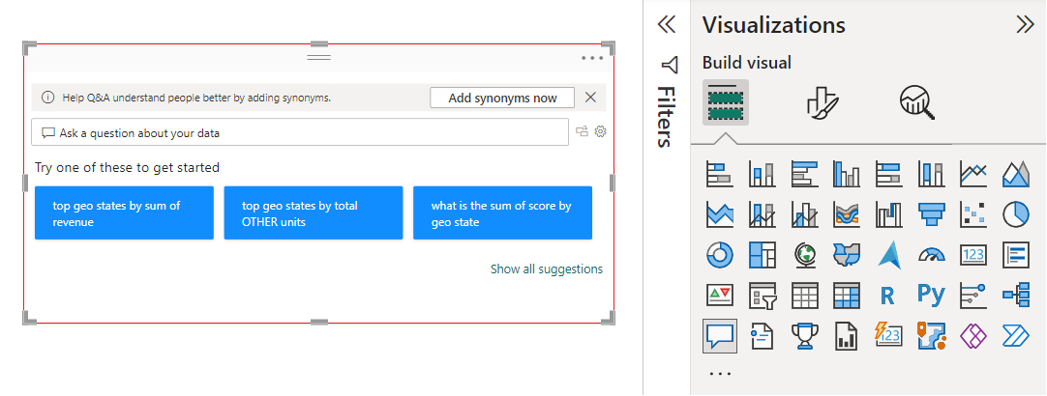

1. To customize your visual, select a suggested question or enter text in the **Q&A question field**, where it says *Ask a question about your data*. In this example, we select the suggestion **top geo states by sum of revenue**. Attention! If this suggestion does not exist in your own PBI sample, type it yourself in the suggestion box.

Power BI determines the appropriate visual type based on the selected suggestion or entered text. Your visual might be different from the one shown below.

## Create Q&A Visuals using our own questions

1. Start entering a question in the **Q&A question field**. Enter "Revenue for VanA".

As you enter text, Power BI adds a red double underline to words it doesn't recognize. When possible, Power BI helps define unrecognized words. The following example shows suggestions from Power BI for an unrecognized term.

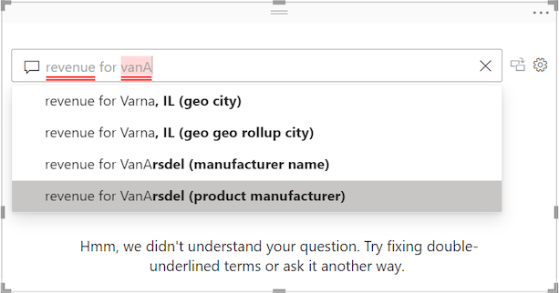

Let's choose the last suggestion in the list.

1. Enter more text for the current question. Enter the following text:  
     
   **Total Revenue for VanArsdel (product manufacturer) by date year**

With Power BI's help, we're able to ask a question with all recognizable terms. Power BI displays the results as a line chart.

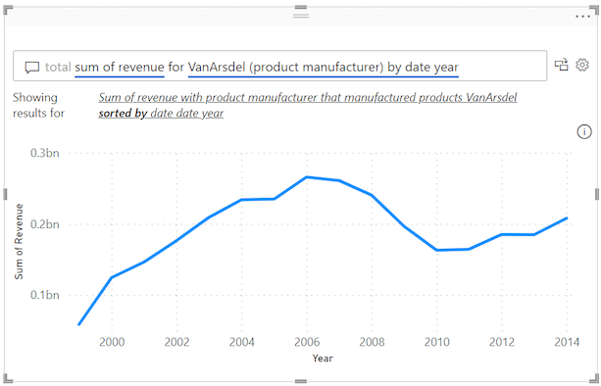

1. Instruct the Q&A visual to show the data in columns by adjusting your question. At the end of your current query, enter the text "as a column chart."

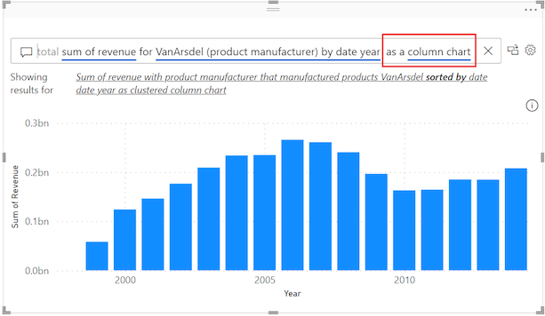

## Format and customize the Q&A visual

The Q&A visual can be customized by using options on the **Visualizations** > **Format visual** pane, and by applying a theme.

## Apply a theme

When you select a theme, the theme is applied to the entire report page. There are many themes to choose from. Explore the themes and test them on your report to find a presentation that works well for your dataset and users.

1. On the Power BI main menu, select **View**, and then select the **Themes** drop-down menu.

[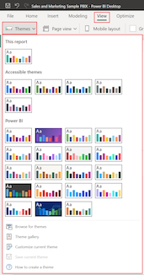](https://learn.microsoft.com/en-us/power-bi/visuals/media/power-bi-visualization-q-and-a/power-bi-themes-expanded.png#lightbox)

1. Let's change the theme for our report. In the **Themes** > **Power BI** section, select the **Colorblind safe** theme. This theme colors all elements in the visual to help ensure all content is readable for people with color blindness. You can choose any theme you want.

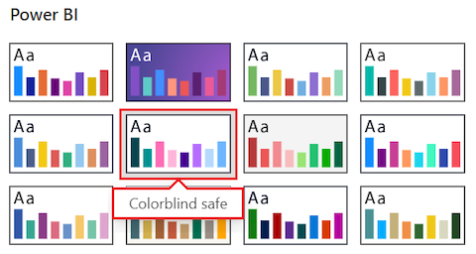

Power BI updates the report view to use the color-blind safe theme:

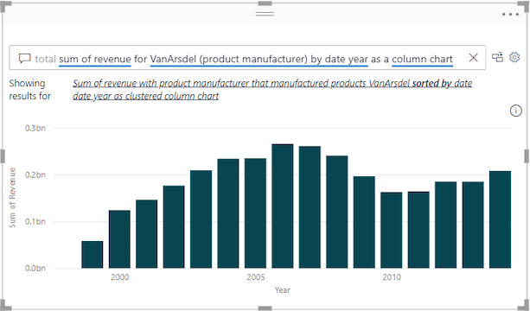

## Format the Q&A visual

Power BI lets you format the Q&A visual, including the **Q&A question field** and how to display suggestions. You can change everything from the background of a title to the hover color for unrecognized words.

1. 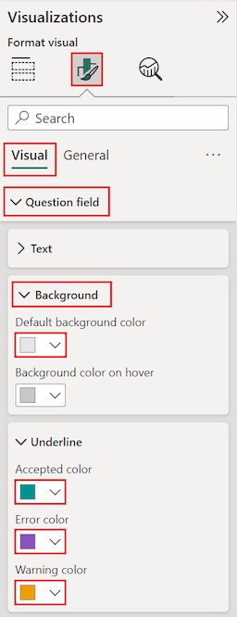In the **Visualizations** pane, click the tab **Format Your Visual.** We will configure settings in the **Question field** section. Add a gray background for the text that appears in the **Q&A question field** and change the underline colors for accepted and unrecognized terms as per the image to the right:

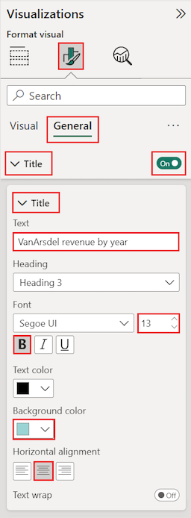

1. Now select the **General** section on the **Visualizations** > **Format Your Visual** pane, and scan the options. In this example, we adjust settings in the **Title** section. We add the title "VanArsdel revenue by year" and center the text on a cyan blue background. First **toggle the Title to On**. Adjust the rest of the settings as per the image to the right.

Here's what our updates look like in the Q&A visual on the report canvas. An unrecognized term "revenue" is shown with a double underline in purple. Power BI indicates a warning for the term "VansArsdel" by applying the dotted underline in orange. Accepted terms are underlined in cyan blue.

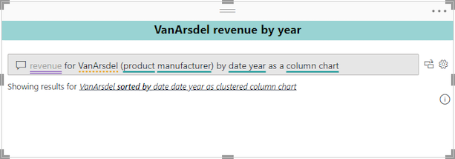

**Convert your Q&A visual into a standard visual**

At this point, you have a Q&A visual that displays data as a column chart. In our example, we added a custom title and custom coloring, and applied the color-blind safe theme. Now you're ready to convert your work into a standard visual in your report. After you have a standard visual, you can pin the visual to a dashboard in the Power BI service.

1. At the top right of the Q&A visual, select the convert icon  to turn the Q&A result into a standard visual.

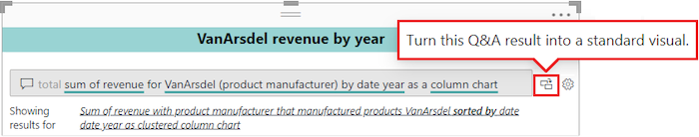

After Power BI completes the conversion, your visual is no longer a Q&A visual. It's now a standard column chart that can be pinned to a dashboard. In your report, this new visual behaves the same as other standard visuals.

1. Select the converted visual and notice the change to the **Visualizations** pane. The standard visual is a **Column chart** and not a **Q&A visual**.

